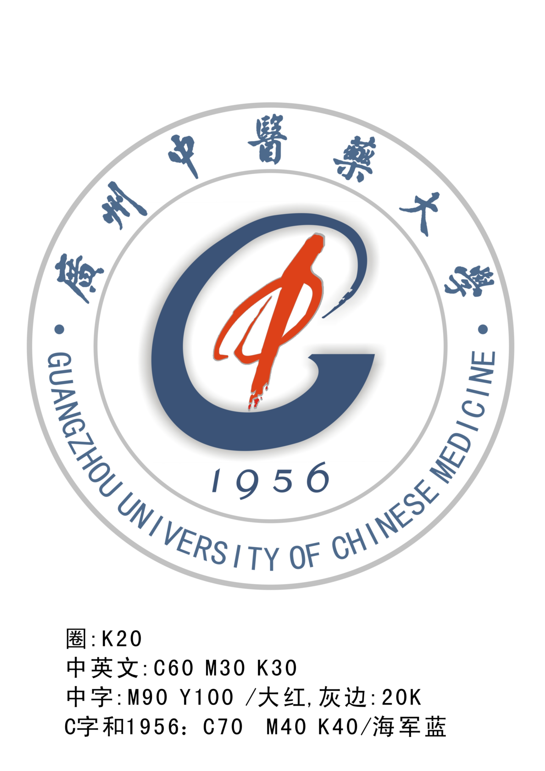


Guangzhou University of Chinese Medicine
中国广州市机场路12号广州中医药大学外国留学生/港澳台学生工作办公室，邮编：510405
Foreign Student Affairs Office & Hong Kong, Macao and Taiwan Student Affairs Office, Guangzhou University of Chinese Medicine, 12 Jichang Road, Guangzhou, 510405, P. R. China
中国广州市大学城外环东路232号广州中医药大学外国留学生/港澳台学生工作办公室，邮编：510006
Foreign Student Affairs Office & Hong Kong, Macao and Taiwan Student Affairs Office, Guangzhou University of Chinese Medicine, University Town Campus, Panyu District, 510006, P. R. China
Tel: (020) 36585503, 39358355 Fax：(020)36586715, 39358478 E-mail: wszsb@gzhtcm.edu.cn Http:// www.gzhtcm.edu.cn

广州中医药大学港澳台、外国留学生入学申请表 (本科生)

Application Form for Hong Kong, Macao, Taiwan and Foreign Students
Guangzhou University of Chinese Medicine（Undergraduate Program）
- 请用中文或英文填写此表/Please complete the form in Chinese or English.
- 请用黑色或蓝色签字笔填写此表/Please complete the form in marker pens.
申请人情况/Personal Information
姓名  Name | 英文姓名（以护照用名为准）  In English (Same as in your Passport) |  |  | 姓/Family name： |  |  |  |  |  | 照  片  Photo
姓名  Name |  |  |  | 名/Given name： |  |  |  |  |  | 照  片  Photo
姓名  Name | 中文姓名（必填）  In Chinese（must fill） |  |  |  |  |  |  |  |  | 照  片  Photo
性别  Sex |  | 国籍/地区  Nationality |  |  |  |  | 婚姻状况  Marital Status |  |  | 照  片  Photo
护照号码Passport No. 有效期至/Valid Until _________年______月_______日
Yr. Mon. Date
出生日期 _________年______月_______日  Date of Birth Yr. Mon. Date |  |  |  |  |  | 出生地 国 家 城市  Place of Birth Country City
身份证号码  Identification No. |  |  |  |  | 家庭住址  Home Address
最后学历  Education Level |  |  |  |  | 毕业学校  Graduated School
申请专业  Field of Study |  |  |  |  | 宗教信仰  Religion |  |  |  | 母语  Native Language
目前所在学校或机构  Place of Study or Work： |  |  |  |  |  |  |  |  | 职业  Occupation
电话/Tel： |  |  | 传真/Fax： |  |  |  |  | Email：
录取通知书邮寄地址/Address for Correspondence
(Please inform the university for any change of this address)

语言能力/Language Proficiency
HSK考试等级 (港澳台学生、全英班除外) / Level of HSK Test (for foreign students of the Chinese-taught Program ) |  |  |  |  |  | 英语能力  English Proficiency
申请人经历/ Experience
申请人保证/I hereby affirm that
1）上述各项中所提供的情况是真实无误的/All the information I provided above is true and correct;
（2）在校学习期间遵守中国政府的法规和学校的规章和制度/I shall abide by the laws of the Chinese Government and the regulations of Guangzhou University of Chinese Medicine.
日期/Date 申请人签字/Applicant’s signature____________________

